SHULL SCIENCE · JAMES A. GARFIELD LOCAL SCHOOLS
UNIT 2 QUIZ C
QUIZ · VERSION C · ELECTRON CONFIGURATIONS AND IONS · TEACHER KEY
NAME | DATE | PERIOD | SCORE / 23

You may use a periodic table. For multiple choice, circle one letter. In an orbital diagram, each electron gets one arrow.

Part 1 Multiple choice | 3 points

1 | Which rule says put one electron in each box before pairing? B Hund, one in each before pairing
1 | A Aufbau principle | B Hund's rule | C Pauli exclusion | D Bohr model
2 | Which orbital diagram for carbon's 2p² follows Hund's rule? D one in each box, same direction
2 | A | B | C | D
  ↑↓
  ↑ | ↓
  ↑↓
  ↑ | ↑
3 | Which sublevel fills right after 4p? D 4p, then 5s
3 | A 4d | B 5p | C 4f | D 5s

Part 2 Longhand configurations and orbital diagrams | 8 points

4 | 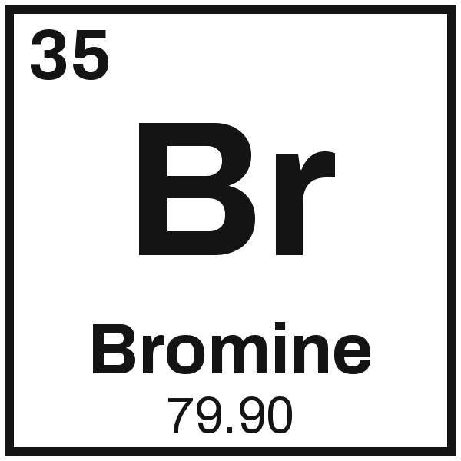 | Configuration 1s² 2s² 2p⁶ 3s² 3p⁶ 4s² 3d¹⁰ 4p⁵
4 |  | Orbital diagram
  1s | ↑↓ | 2s | ↑↓ | 2p | ↑↓ | ↑↓ | ↑↓ | 3s | ↑↓ | 3p | ↑↓ | ↑↓ | ↑↓ | 4s | ↑↓ | 3d | ↑↓ | ↑↓ | ↑↓ | ↑↓ | ↑↓ | 4p | ↑↓ | ↑↓ | ↑

5 | 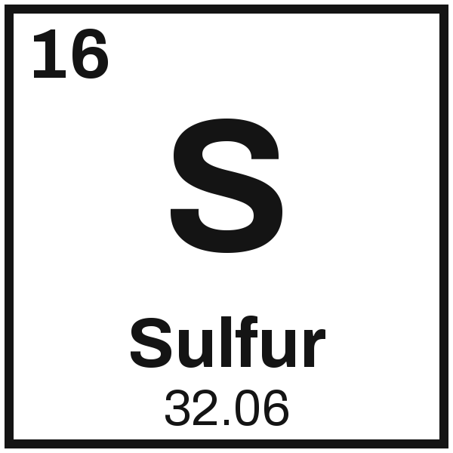 | Configuration 1s² 2s² 2p⁶ 3s² 3p⁴
5 |  | Orbital diagram
  1s | ↑↓ | 2s | ↑↓ | 2p | ↑↓ | ↑↓ | ↑↓ | 3s | ↑↓ | 3p | ↑↓ | ↑ | ↑

Part 3 Noble-gas shorthand | 4 points

6 | 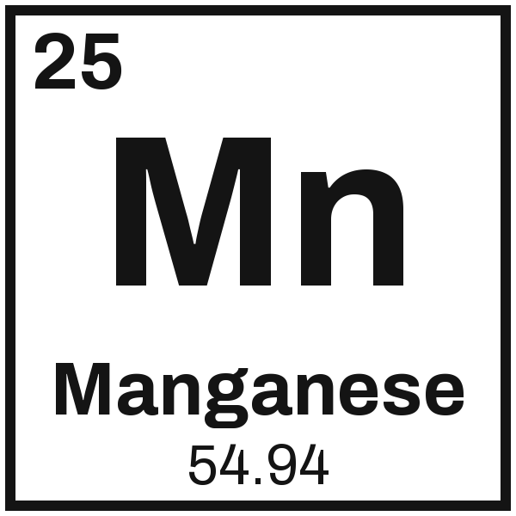 | [Ar] 4s² 3d⁵ | 7 | 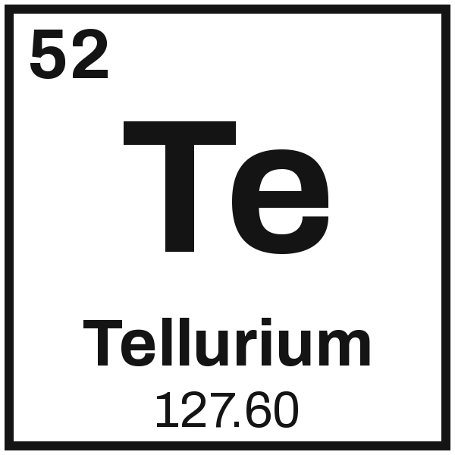 | [Kr] 5s² 4d¹⁰ 5p⁴

Part 4 Ions: the charge, and cation or anion | 8 points

8  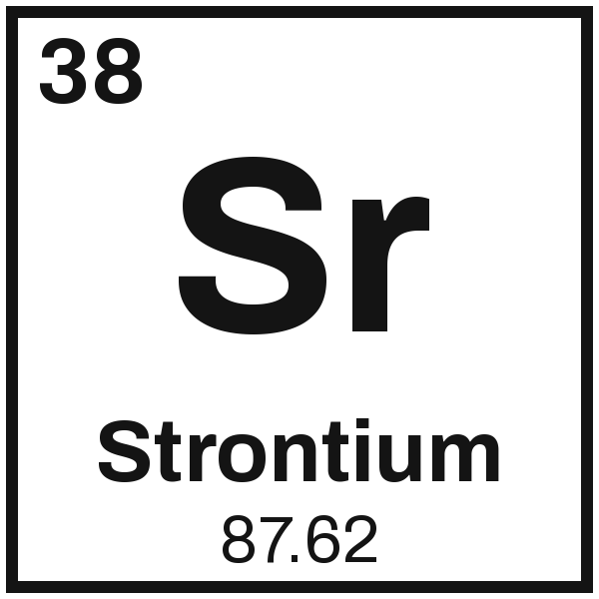  Charge 2+  cation or anion  2 val. e-, loses 2 | 9  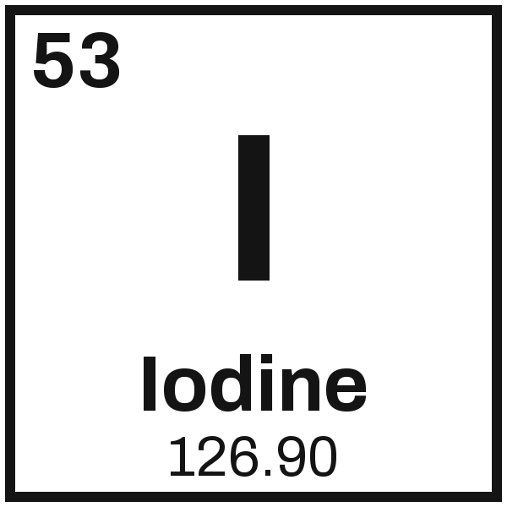  Charge 1−  cation or anion  7 val. e-, gains 1 | 10  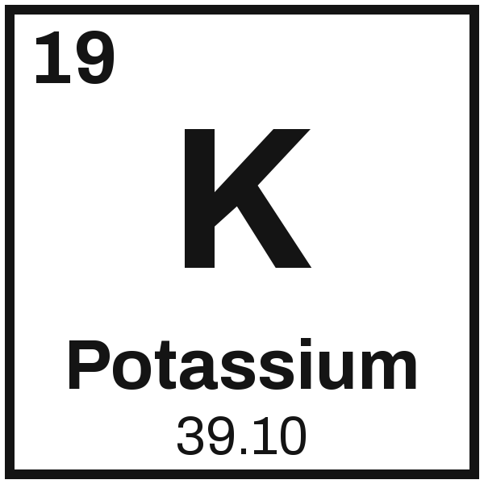  Charge 1+  cation or anion  1 val. e-, loses 1 | 11  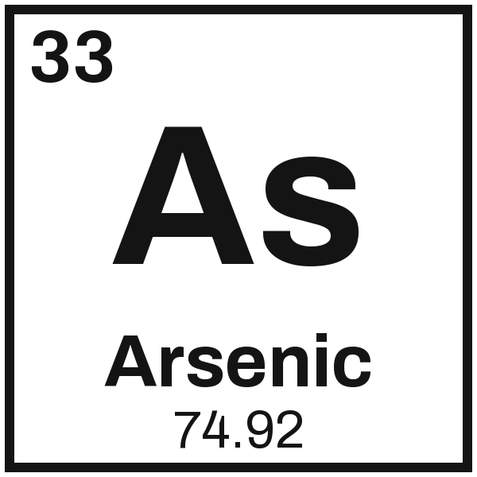  Charge 3−  cation or anion  5 val. e-, gains 3

